PROJECT EXPO-26
PHASE 2: Ideation & Concept Development

SECURE MOBILE WEB-BASED REMOTE VOTING SYSTEM

Team Members: Vaishika T.A, Ezhilvizhi R,
Sowmiya A, Babykarthika S

BRAINSTORMING REPORT:

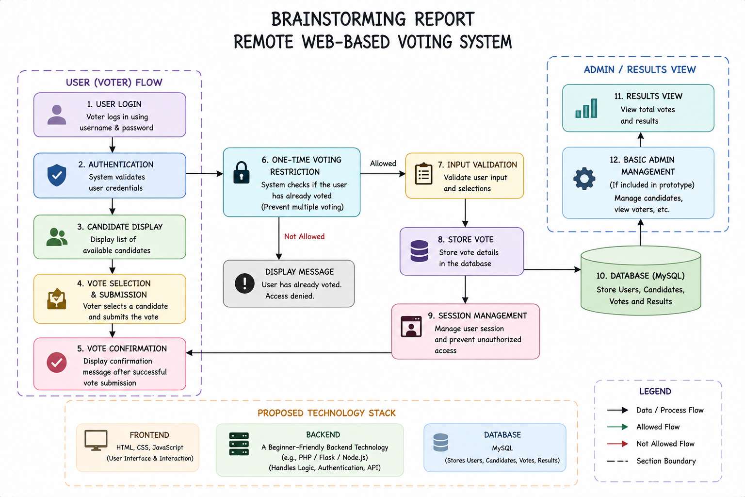

Idea Prioritization Matrix :

Idea | Impact | Feasibility | Priority
Username/Password + Voter ID Login | High | High | Most Priority
One-time Voting Restriction | High | High | Most Priority
Admin Panel | High | High | Most Priority
Database Logging (Anonymized) | High | High | Most Priority
HTML/CSS/JS Frontend | High | High | Most Priority
HTTPS/SSL Encryption | High | Medium | Medium Priority
Role-Based Access | Medium | High | Medium Priority
Vote Confirmation Message | Medium | High | Medium Priority
Real-Time Vote Count (Admin) | Medium | Medium | Low Priority
Responsive UI | Medium | Medium | Low Priority
Session Timeout | Low | Medium | Low Priority

Priority Legend: Green = Most Priority | Yellow = Medium Priority | Red = Low Priority

Empathy map:

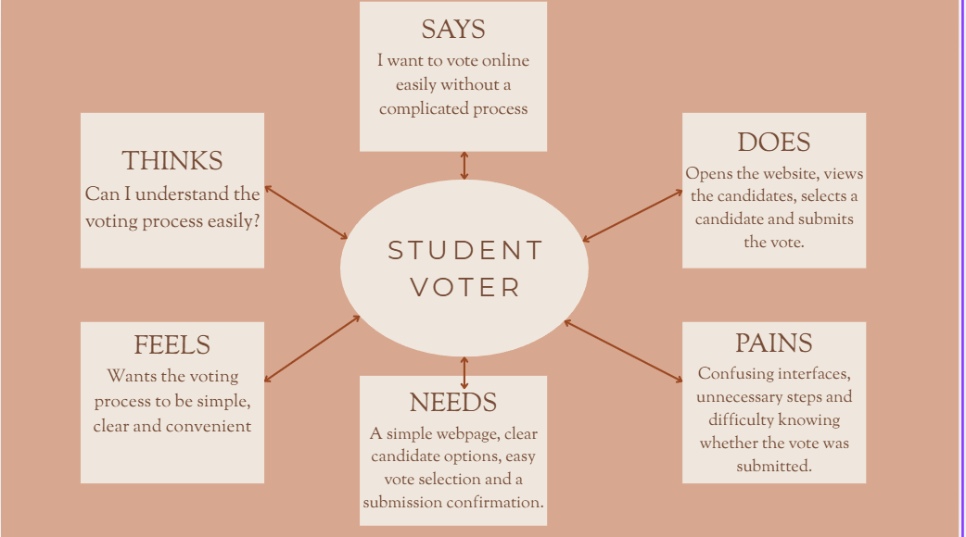

USER PERSONA:

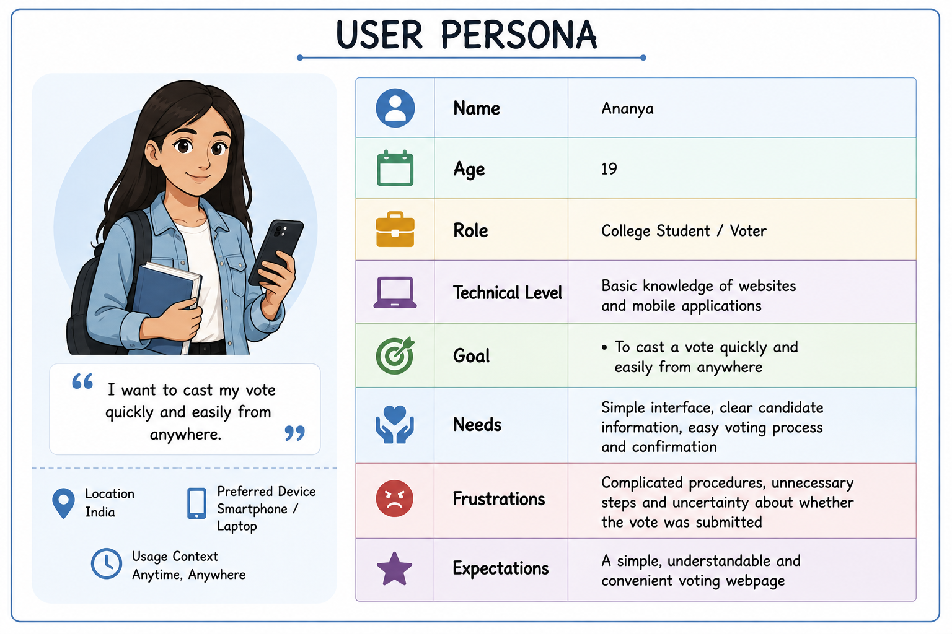

PROPOSED SOLUTION:

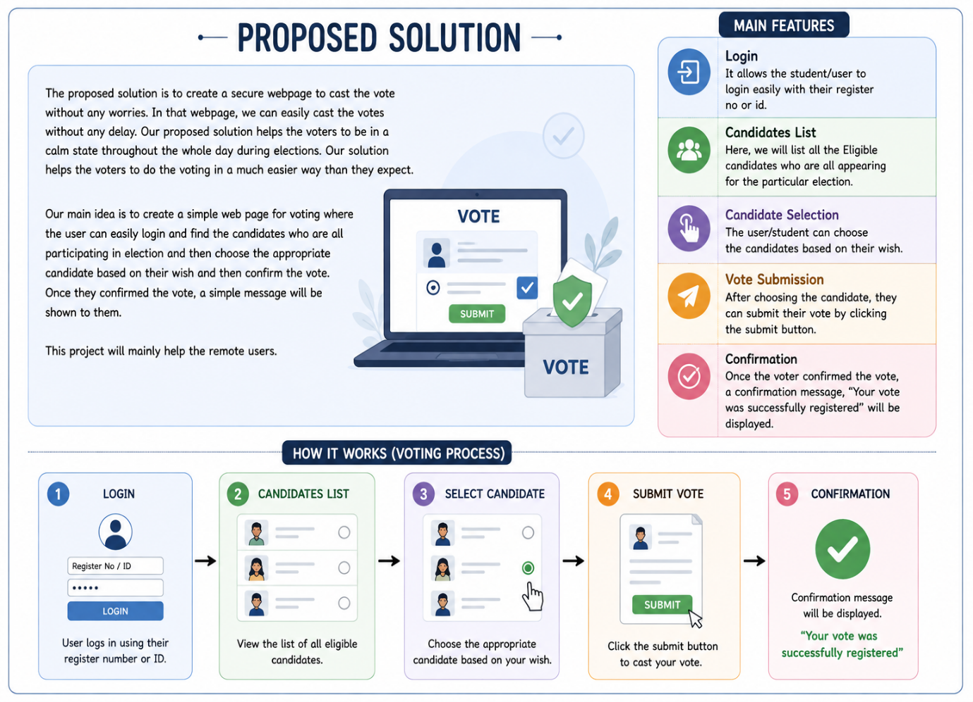

FUNCTIONAL REQUIREMENTS:
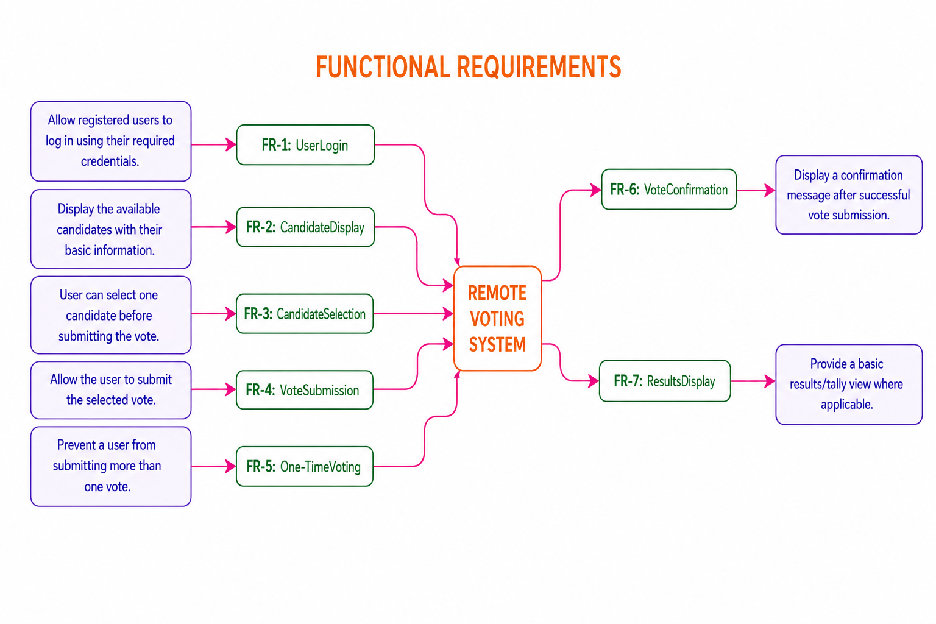NON-FUNCTIONAL REQUIREMENTS:
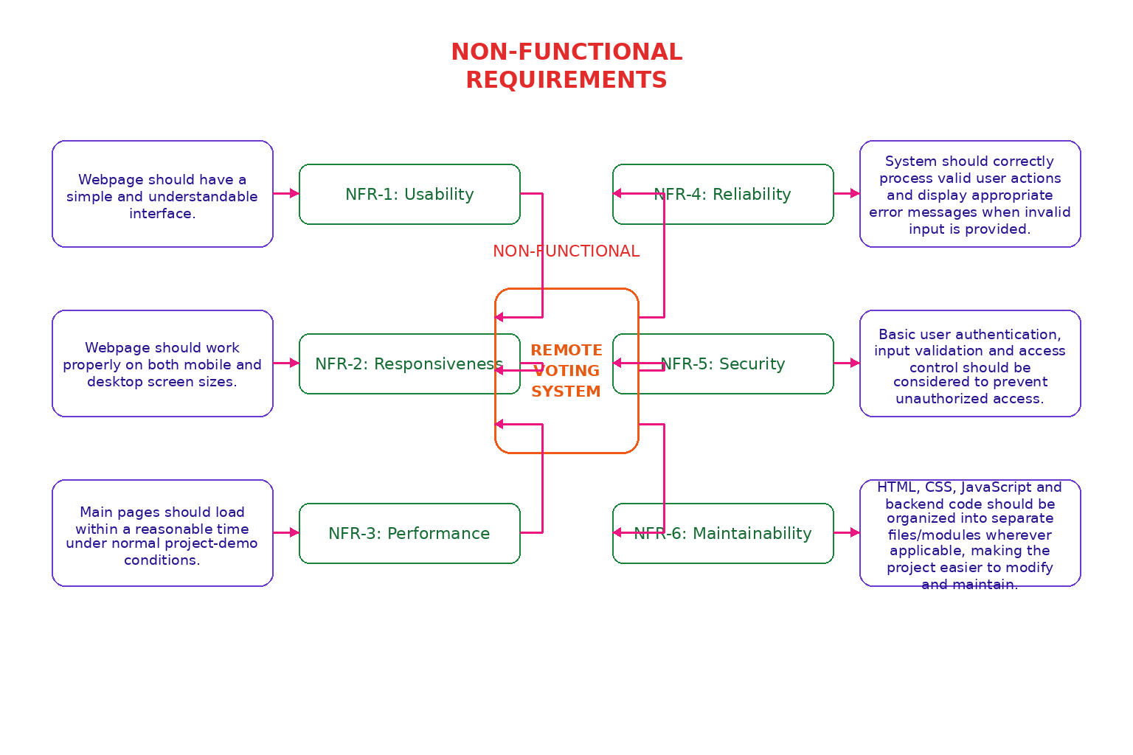

PROJECT PLANNING:

Week 1 – Planning & Design | Finalize the basic voting features, prepare the user flow and create simple webpage wireframes.
Week 2 – Webpage Development | Create the basic webpage structure, login page and candidate display page using HTML/CSS.
Week 3 – Voting Process | Implement candidate selection, vote submission and confirmation page. Connect the required backend/database if included in the prototype.
Week 4 – Integration & Testing | Connect the pages, test the voting flow, check form inputs and verify that the basic system works correctly.
Week 5 – Finalization & Demo | Fix errors, improve the interface, prepare documentation and demonstrate the completed prototype

RISK ANALYSIS:
